Alan Wang

16.90

Project 1

**Problem 1**

See attached pages for Problem setup and derivation of f(U)

**Task 1**

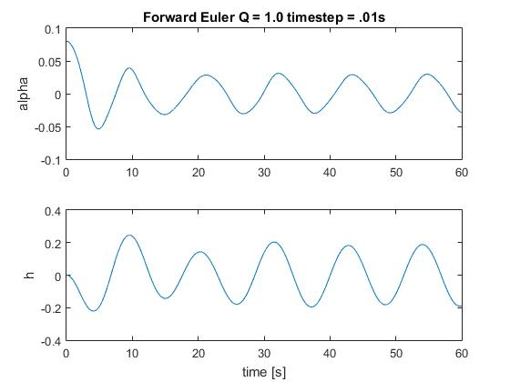

Figure 1: Solution using Forward Euler Method with time step of .01 at Q = 1.0

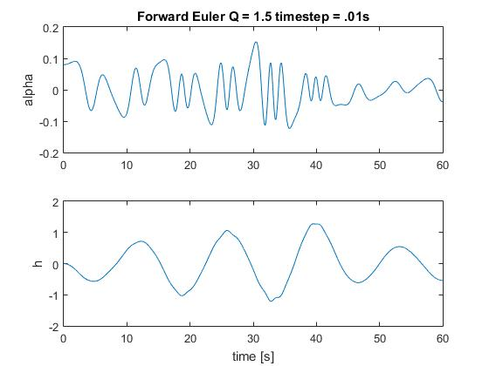

Figure 2: Solution using Forward Euler Method with time step of .01 at Q = 1.5

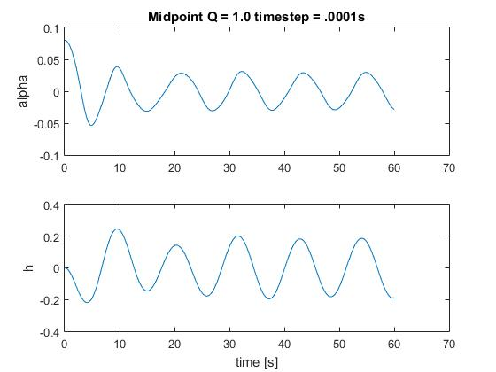

Figure 3: Solution using Midpoint Method with time step of .0001 at Q = 1.0

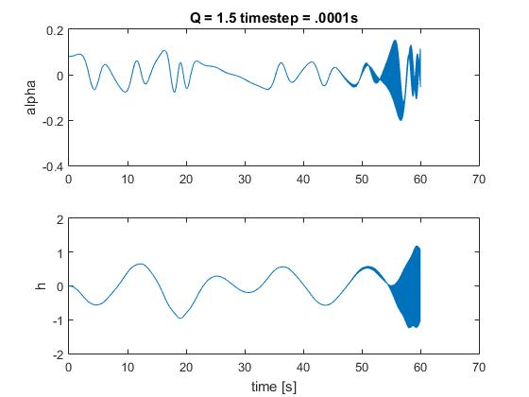

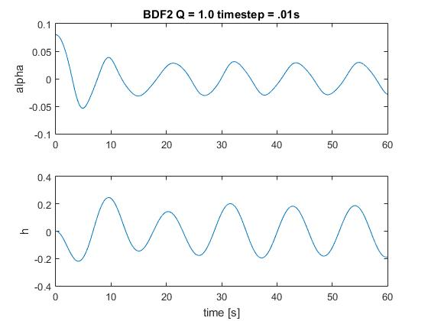

Figure 4: Solution using Midpoint Method with time step of .0001 at Q = 1.5

Figure 5: Solution using BDF2 with time step of .01 at Q = 1

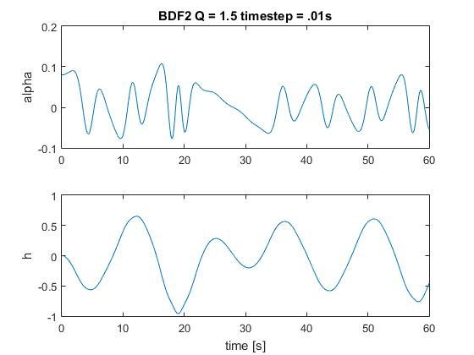

Figure 6: Solution using BDF2 with time step of .01 at Q = 1.5

Figures 1 and 2 show solutions for the plunge and pitch with an initial pitch of 0.08 radians using the Forward Euler method, Figures 3 and 4 show solutions for the Midpoint Method with a time step of 0.0001, and figure 5 and 6 show solutions for BDF2. The first figure for each method uses a value of 1.0 for Q and the second figure uses a value of 1.5 for Q. At Q = 1.0, the oscillations for all methods are fairly regular and have a constant frequency. At Q = 1.5 the plunge solution for the Forward Euler Method maintains fairly regular oscillations with constant frequency, but the pitch solution oscillates irregularly. An important note is that the pitch and plunge oscillate at different frequencies. The Midpoint method oscillates irregularly for both the pitch and plunge for Q = 1.5. As seen from the figures, despite using a time step 100 times smaller than the Forward Euler time step, the Midpoint method also begins to oscillate very heavily after about t = 50 seconds. For BDF2 at Q = 1.5, the pitch oscillates irregularly and at a different frequency than plunge.

Error:

The local error for the Forward Euler method is O(deltat^2) with a global order of p = 1. The local error for the Midpoint method is O(deltat^3) with a global order of p = 2. The local error for BDF2 is also O(deltat^3) with a global order of p =2.

The error for the midpoint method increases as the time step increases. These errors are reduced for smaller sized time steps which is why a smaller time step was used for the Midpoint method compared to the Forward Euler Method. Despite beginning to oscillate heavily after t = 50 seconds for Q = 1.5, the midpoint method is still considered convergent because the errors decrease as a smaller and smaller time step is used.

Efficiency:

The Forward Euler Method and Midpoint Method require the same amount of calculations for each time step. However, the time step used for the midpoint method was 100 times smaller than the time step used for the Forward Euler Method. For this reason, the Midpoint method required a factor of 100 times more work than the Forward Euler Method. BDF2 is an implicit method and requires an iterative method such as Newton Raphson to solve. Each step of BDF2 will take longer to solve than a step of Forward Euler or Midpoint. However, due to the 100 times decrease in step size of the midpoint method, the overall run time of the midpoint method was longer than the overall run time of BDF2. Despite taking higher computational power, BDF2 seems like the best scheme for this system due to its lower error compared to the Forward Euler Method.

**Task 2**

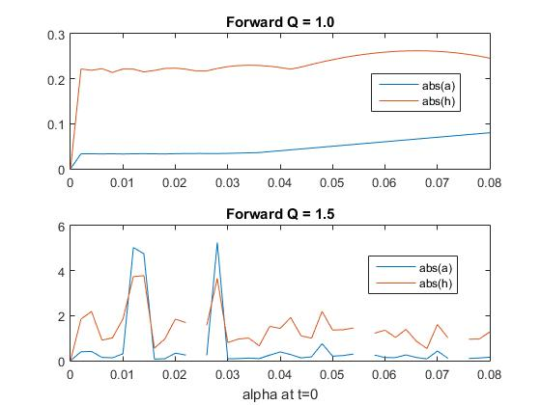

Figure 7: Maximum Absolute pitch and plunge on t=[0,60] vs Initial Pitch

Figure 7 shows the Forward Euler method maximum absolute value of pitch and plunge from t=0 to t=60 vs. initial pitch angle which varies from 0 to 0.08. At Q = 1, the magnitude of pitch and plunge is smooth and only changes slightly as the initial pitch angle varies. The magnitude of alpha here simply increases as the initial alpha increases for a max abs(alpha) at initial pitch of .08. For the plunge, there is a maximum of about 0.26 at an initial pitch of about .065. At Q = 1.5, the magnitude of pitch and plunge is not smooth. In fact, there are breaks in the plot where the magnitude blew up to infinity. Disregarding these explosions, there appears to be a peak about an initial pitch of about .0275 where pitch is about 5.2 and plunge is about 3.8. Due to the chaotic nature of the solutions for Q = 1.5, I am not that confident in these maximum plots. In addition, the magnitude of pitch reaches values well above its expected range which also makes me doubt the validity of this plot.

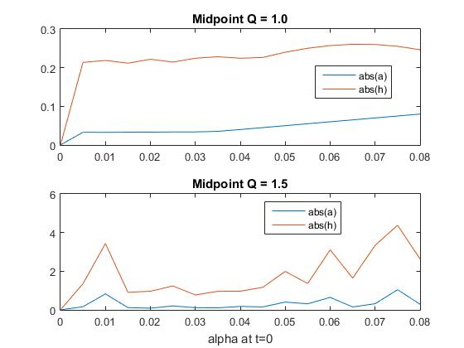

Figure 8: Maximum Absolute pitch and plunge on t=[0,60] vs Initial Pitch

Figure 8 shows the Midpoint method maximum absolute value of pitch and plunge from t=0 to t=60 vs. initial pitch angle which varies from 0 to 0.08. Again, for Q = 1.0, the magnitudes for pitch and plunge vary smoothly. There is a peak for plunge again at initial pitch of around .065. For Q = 1.5, the solution is chaotic once again. There are peaks for both plunge and pitch at the initial pitch of .075. A smaller step size of alpha was used for the midpoint method to save computational time. I am not that confident again because of the chaotic nature of the solution. At least, for the midpoint method, alpha stays within a reasonable range.

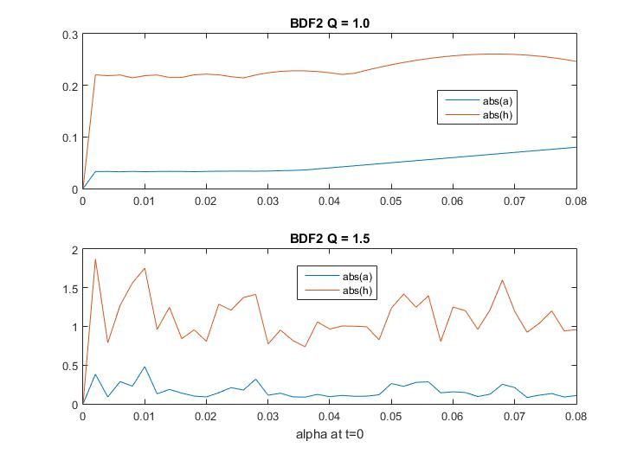

Figure 9: Maximum Absolute pitch and plunge on t=[0,60] vs Initial Pitch

Figure 9 shows the BDF2 method maximum absolute value of pitch and plunge from t=0 to t=60 vs. initial pitch angle which varies from 0 to 0.08. The magnitude of pitch and plunge for Q = 1 using BDF2 is also smooth. Pitch increases as initial pitch increases. Plunge has a maximum at around an initial pitch of .065. For Q = 1.5, the magnitudes of pitch and plunge are chaotic once again. There is no clear peak for either pitch or plunge, but they both reach relative maximums at around an initial pitch of .002, .01 and .068.